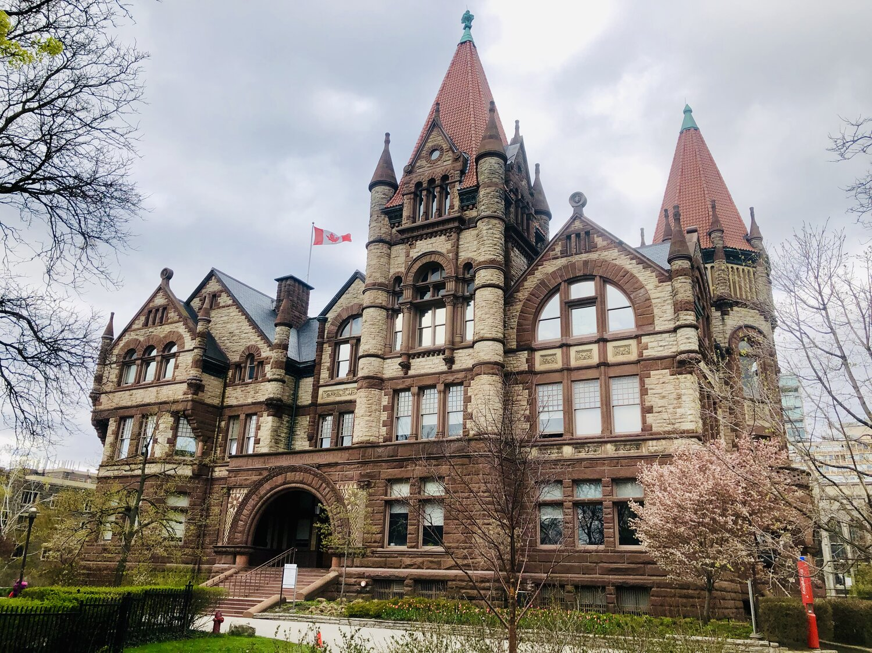

Fall 2021 Elections Report

Prepared by:
Malhaar Moharir
Chief Returning Officer

Introduction:
As per the Elections and Referenda Code, Chapter 23, this report will detail the organization and outcome of the Fall 2021 Victoria University Elections. It will be sent to each member of VUSAC, every candidate in this term’s elections as well as the members of the Elections and Appeals Committee. Furthermore, this report is intended to serve as part of the transition process for future CROs, and as such should serve as a useful guide for next steps and planning.
Dates of the election
DATES & TIMES | IMPORTANT EVENTS
Thursday August 26. 2021  10:00am-11:00 am | Q&A Session
Tuesday August 31, 2021  8:00pm-9:00pm | Q&A Session
Friday September 3, 2021 | Nominations Open
Friday September 10, 2021  4:00pm - 6:00pm | Q&A Session
Thursday September 16, 2021  5:30pm - 7:30pm | Q&A Session
Friday September 17, 2021  12:00pm | Nominations Close
Friday September 17, 2021 8:00pm - 9:30pm | All-Candidates Meeting
Saturday September 18, 2021 - Friday September 24, 2021 (9PM) | Campaigning Period
Friday September 24, 2021  6:00pm - 9:30pm | Town Hall
Saturday September 25, 2021  12:01am | Voting begins online
Tuesday September 28, 2021  11:59pm | Voting ends
Wednesday September 29, 2021 | Results announced to candidates only; Appeals Period begins at 12:01 am
Thursday September 30, 2021  11:59pm | Appeals Period ends
Friday October 1, 2021 | Results posted online; Results ratified at VUSAC meeting

EAC Members:
Zach Groves
Jacob Kim
Saara Meghji
Maya Shankar
Angelina Zhang
Kevin Zhu
Official results
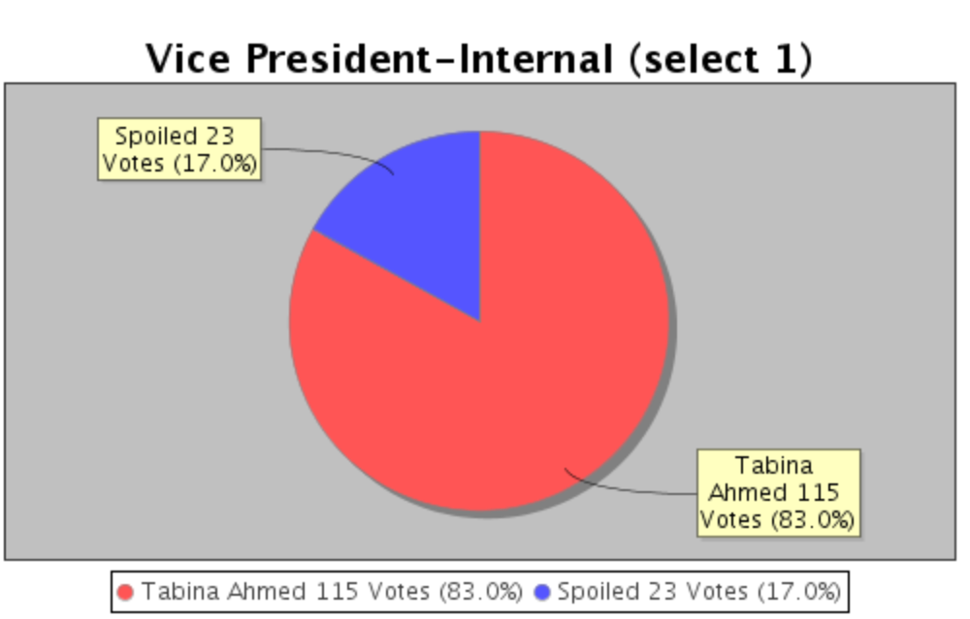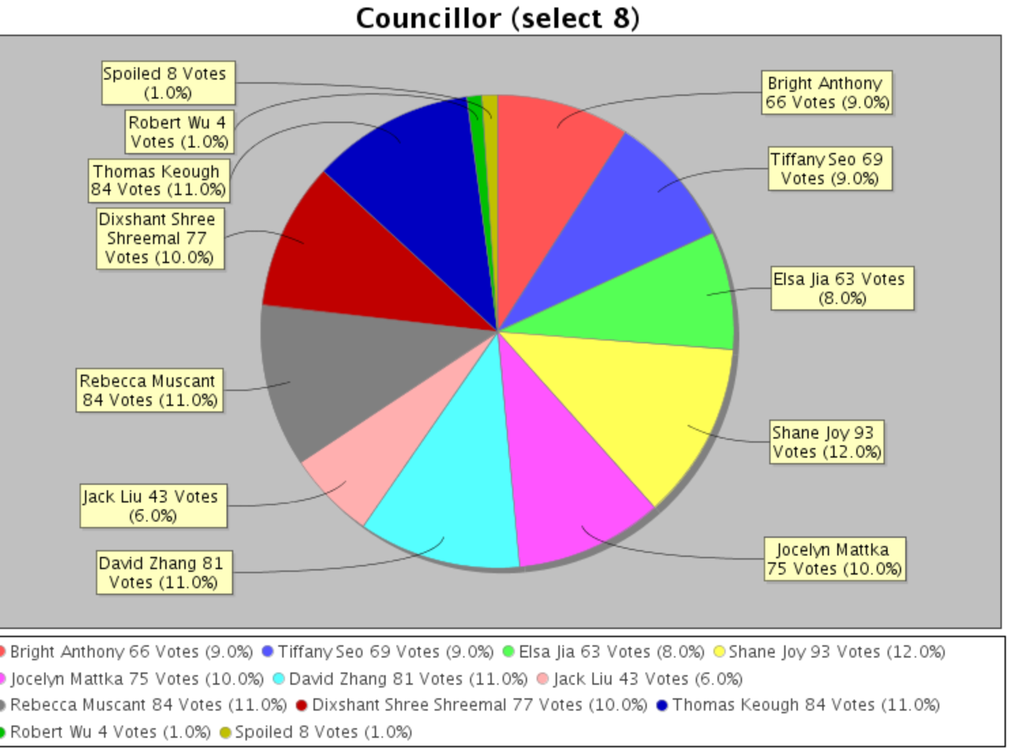

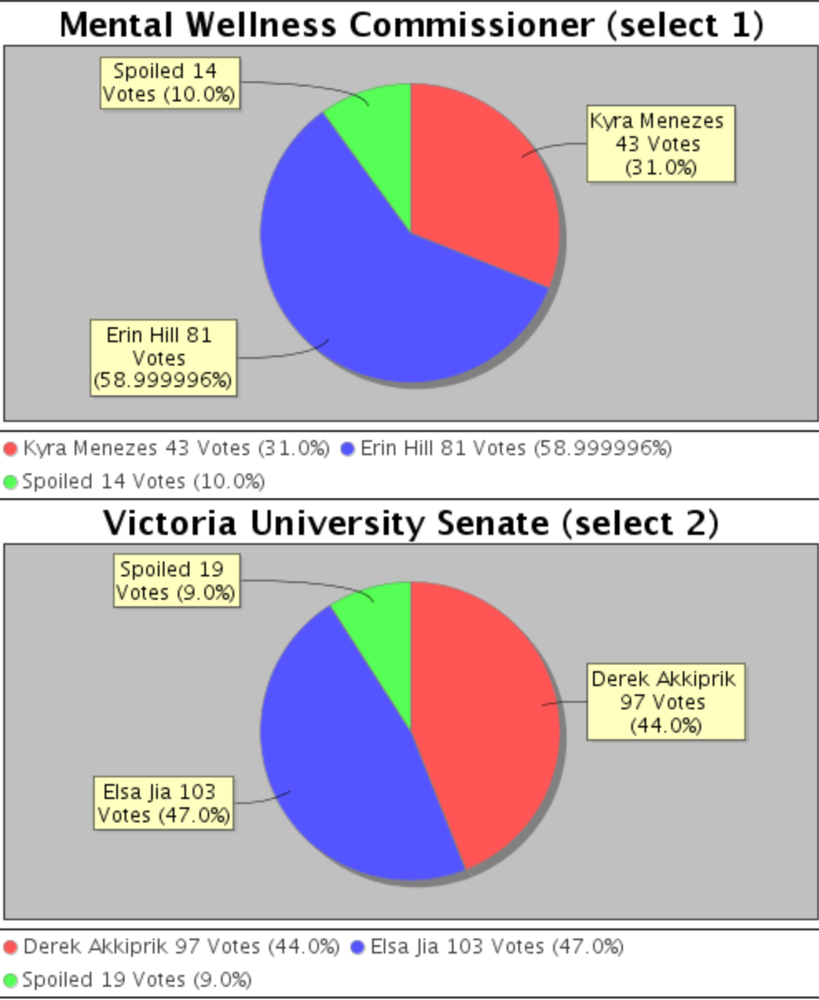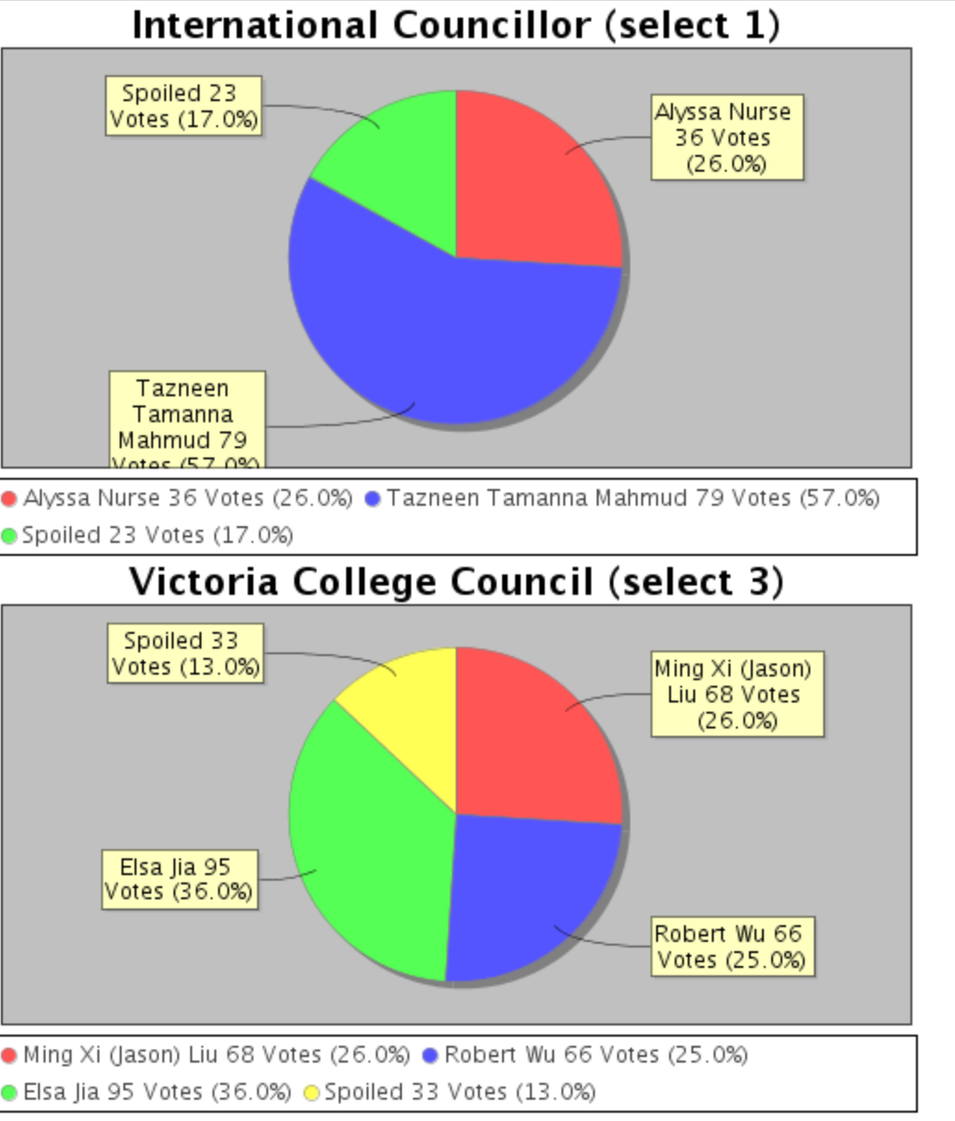

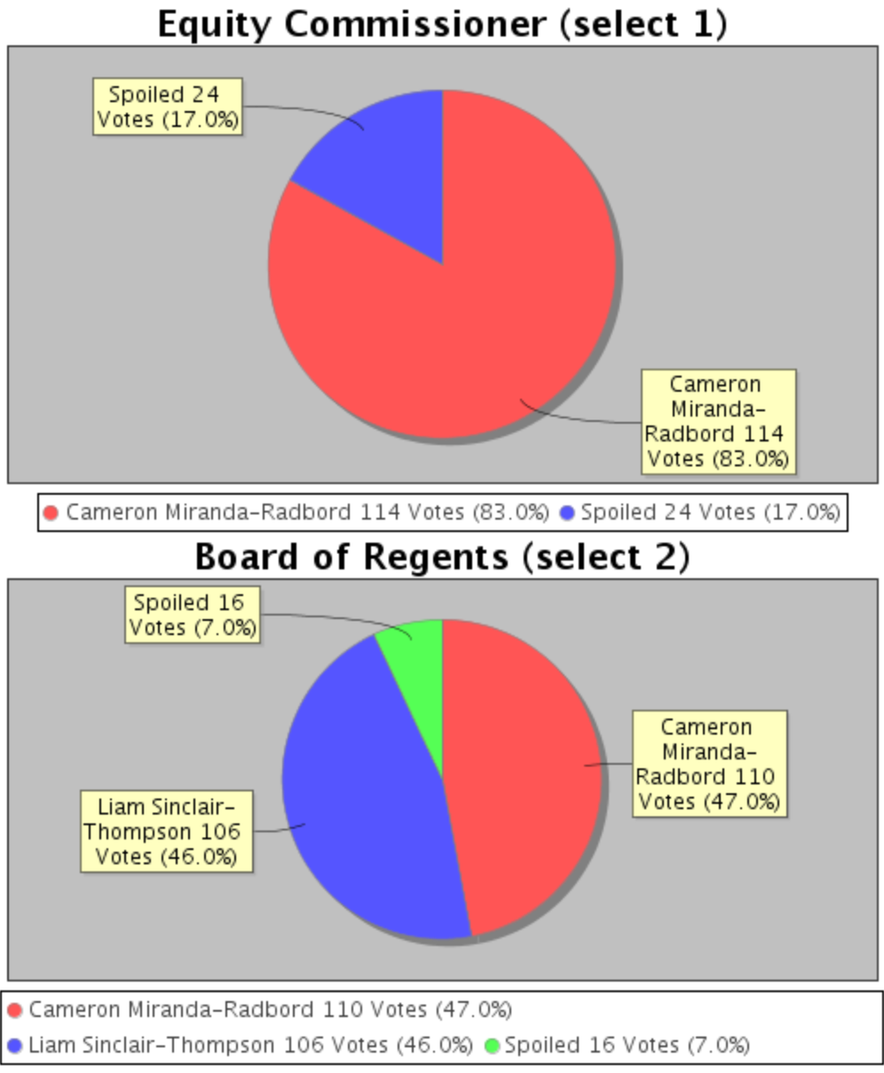
Additionally, it should be noted that two positions: the Arts and Culture Commissioner and the Commuter Commissioner were uncontested in these elections. These positions are typically elected during the spring elections, however, due to the lack of candidates, this election cycle served as a by-election for these positions. Once again, due to the lack of interest in these positions, as per S7b) of Chapter XII: Elections in the VUSAC Constitution, the Executive appointed Alyssa Nurse as Arts & Culture Commissioner and Mary Cortiñas as Commuter Commissioner.
Pre-nomination period:
The pre-nomination period began with the hiring of myself, the current CRO in May 2021. In the leadup to the nominations period, I had a few meetings with the former Vice President-Internal, Nerija Gray as well as the current President Jerico Raguindin to discuss elections planning. As the elections were run completely online, most of our planning was focused on boosting promotion over social media and establishing a solid timeline for events and activities.
We hosted two Q&A sessions before the period opened, and we actually had quite a few interested individuals attend, many of whom would run as candidates in the election. This suggested that promotion before the nomination opening date, which was posting information on our social media and sending out emails, was fairly useful. Additionally, during this time, and spilling into the nominations period, we tried to get IG takeovers from former students in a number of positions. Personally, I don’t think this was as effective; they should have been planned out a little more. The overall goal was obviously to get people to run, but for a number of positions, especially the ex-officio ones, the responsibilities, time commitments, objectives, etc. weren’t made clear enough to students. I do like the idea of IG takeovers, but we can definitely set out clearer expectations of the content we want to see.
And finally, the nominations package was approved by all necessary parties before September 3. The biggest change which Jerico and I decided was to reduce the number of nominators required for all the positions except for the ex-officio ones. For the VPI position, the number was reduced to 10 from 15; the commissioner positions from 10 to 5, and the councillor positions from 5 to 1. We felt like the bar with the original number was far too high for an online-only election and hoped that the reduced number might encourage more students to run for positions.
Nomination period:
The nominations period also went quite smoothly with no glaring issues. Every candidate sent in their nominations package and each was correctly filled out, so props to us for making that process easy to fill out!
However, the biggest problem we had with nominations was actually getting enough people for most of our positions. Councillor nominations were pretty quickly filled up, and given that the vast majority of them were first or second years, shows great enthusiasm on their part. However, aside from that position and the Mental Wellness Commissioner position, we either did not sufficiently meet or just met the minimum required nominations for the position. For example, for the BoR position, we managed to get 2 nominations for 2 seats, whereas for Arts & Culture and Commuter Commissioner Positions, we had 0.
Thus, we had to extend the nominations period for all positions except the Councillor and Mental Wellness Commissioner positions by three days, from Friday, September 17 to Monday, September 20. This slightly helped, as we got a number of candidates interested in a few positions, like BoR and International Councillor.
The All Candidates Meeting went pretty well, with almost everybody in attendance. They asked really good questions and got us to clarify a lot of points that we were uncertain about. Most of the information remained the same from previous years
Campaign period:
Campaigning period went a little differently this time around, because, as was mentioned in the previous section, we had to extend nominations. Thus, to ensure equity and fairness as per the ERC and Vic Constitution, we decided to only open campaigning following Town Hall to Councillor and Mental Wellness Commissioner positions, with campaigning officially opening to everyone following the impromptu Town Hall we held on the Monday. I did have some reservations about having a reduced campaigning period for everyone but given that everyone campaigning for the same position had the same time, it was fine in the end. I do think that maybe we could change protocol that could extend the campaigning period by a few days for everyone, that way everyone has the minimum 5 days of campaigning that is accorded to them.
Campaigning primarily took place over social media, specifically Instagram. On the VUSAC Instagram page, we gave the candidates opportunities to put out a ‘graphic’, which we would put out. I think this worked pretty well, as it provided one platform where there could be a relatively even ground for all of them. For the Spring Elections, we could probably formalize this more by creating a better organized template and guidelines (e.g. formatting or content). This could also tie into perhaps an even larger ‘handbook’ or how-to document for candidates on tips for campaigning.
One thing that we really need to emphasize is tagging VUSAC and the CRO on Instagram posts and stories. While obviously I and the rest of VUSAC did our best to ensure that posts were following all our rules and adhered to the ERC, there evidently were cases which escaped our attention, and as such, I think we could come up with a better way for managing this system.
Furthermore, I don’t think we really need to use Facebook as an official media platform anymore, seeing as we didn’t really have any engagement with that from our candidates or the general student body, and the fact that we weren’t able to advertise any posts on the site due to technical purposes. To clarify, we could still let candidates campaign over Facebook and Messenger, but there wouldn’t be any official VUSAC promotion on the site anymore.
At the end of the campaigning period, as usual, we had Town Hall. Overall, I would say that Town Hall was the most successful aspect of the Fall Elections. As we had decided before, Town Hall would be held completely online, over Zoom, and to be honest, I was not expecting it to go that great (three hours in a Zoom call with speeches and Q&A periods seemed like it would be too long). Before Town Hall, we had created a Google Form where any member of the VCU could submit questions to the candidates, anonymously if they so wished. We had about 6 or 7 questions submitted on the Google Form, and the rest Jerico and I came up with on a separate Google Sheet for each position before the hall. The format of town hall went like this: position speeches followed by position specific questions and answers. Mostly, the Exec asked questions directly in the Zoom Chat that I then read out, but we also asked some of our pre-thought out questions. To keep the rest of the candidates engaged, especially when we had finished with their position, we created a list of general candidate questions (e.g. like why do you want to be on VUSAC, what does Vic mean to you, etc.) We found that this kept most people engaged quite a while, and also allowed people to feel like they were becoming part of the Vic community more. Feedback for Town Hall was also quite good, with a lot of people saying that they were nervous about presenting their speeches and answering questions, but that as they got in to Town Hall more, they grew more comfortable and begun to enjoy it a lot more.
Voting period:
Voting period, which officially began after the Town Hall ended also went quite smoothly. I received no complaints from anybody regarding technical issues with the system, and everybody’s candidate statements were visible underneath the positions. To boost voting and engagement, we were planning on having a raffle system at the end, where a few ho voted could win some small prize, but for privacy considerations, we found this difficult to implement. I would like to spend some time thinking about how we could try and implement this for Spring and Fall elections in 2022 as part of a larger strategy of boosting engagement with elections.
Penalties issued:
Luckily, this elections period was overall quite clean, and zero strikes were issued throughout its course. One concern that I did have did regarding the grey areas of online campaigning did manifest in me having to give two official warnings to a candidate for third-party campaigning on a WhatsApp group chat. Having spoken to the candidate, I came to the conclusion it was an honest mistake on the candidate’s part. Both of us tried our best to have the messages removed, but due to WhatsApp’s technological features, this was not possible. Consequently, I think this serves as a good example of the comprehensive review that the ERC needs prior to the Spring Elections. I really want to make sure that rules for campaigning, both in-person (fingers crossed we get to do this in the spring) and online (which is only going to become more prevalent) are airtight and leave as little room for grey areas as possible.
Conclusion:
Overall, I would say that the elections were run quite successfully from an organizational perspective, but there’s a lot of room for improvement from an engagement and promotional point of view. There are a number of ways I think we can change the way elections are run for the better in the Spring and Fall. Firstly, we should conduct a comprehensive review of the ERC to ensure that regulations and rules are airtight for succeeding elections but also flexible enough to accommodate a variety of circumstances, especially extraordinary ones like what we have had to undergo the past couple of years.
Furthermore, I would like to establish an Elections Planning Committee, which could simply be an extension of the ERC. Hopefully consisting of VUSAC members who ran in the most recent elections, I think having some kind of body (with maybe 3-4 members) to help with brainstorming and implementing fun and engaging election-related promos would do well to bolster both the number of candidates and number of voters, which again was abysmally low this time around.
This concludes the fall transition report, and one thing I would like to say is thank you to everyone who participated in the Fall 2020 Elections. To the candidates, I would like to applaud each and every one of you for simply running. Regardless of whether you won or lost, all of you showed great enthusiasm and dedication, and these elections obviously could not have taken place without you! Additionally, I would like to thank Jerico and Anne, both of whom helped out tremendously in making my job as easy as possible, with promotions, facilitating Q&A sessions, designing graphics, etc.; the elections would not have run nearly as smoothly without your invaluable support.
Appendices:
Elections and Referenda Code
Sample Budget
Appeals Form

